**Week 6: ReactJS**

**EX.NO:1 Creating new React application**

**Code:**

import React from 'react';

function App() {

return (

<div>

<h1>welcome to the first session of React</h1>

</div>

);

}

export default App;

**OUTPUT:**

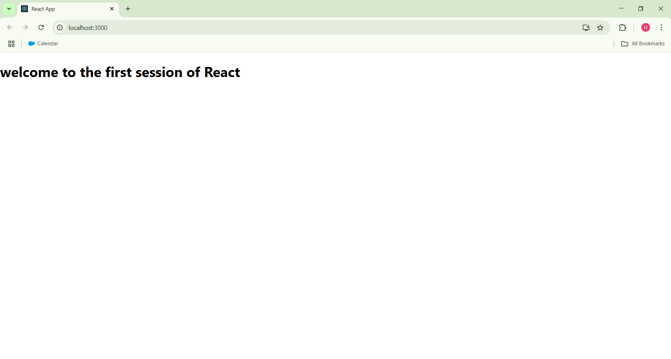

**EX.NO:2 Create React app for Student Management Portal named StudentApp**

**CODE:**

App.js:

import React from 'react';

import './App.css';

import Home from './Components/Home';

import About from './Components/About';

import Contact from './Components/Contact';

function App() {

return (

<div className="App">

<h1>Student Management Portal</h1>

<Home />

<About />

<Contact />

</div>

);

}

export default App;

**OUTPUT:**

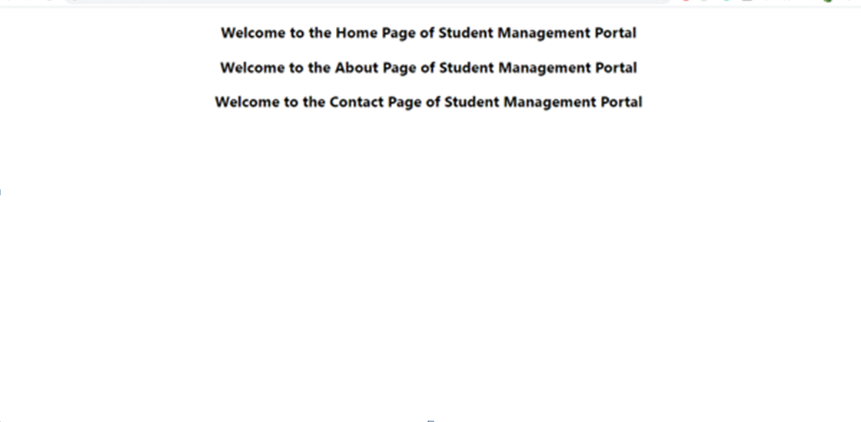

**EX.NO:3 Create a react app for Student Management Portal named score calculatorapp**

CODE:

mystyle.css:

/* src/Stylesheets/mystyle.css */

.container {

width: 400px;

margin: 50px auto;

padding: 20px;

background-color: #f1f1f1;

border-radius: 10px;

text-align: center;

}

input {

display: block;

width: 90%;

margin: 10px auto;

padding: 8px;

border-radius: 5px;

border: 1px solid #ccc;

}

button {

padding: 10px 20px;

border: none;

background-color: #0077cc;

color: white;

border-radius: 5px;

cursor: pointer;

}

button:hover {

background-color: #005fa3;

}

p {

margin-top: 20px;

font-weight: bold;

}

App.js:

/* src/Stylesheets/mystyle.css */

.container {

width: 400px;

margin: 50px auto;

padding: 20px;

background-color: #f1f1f1;

border-radius: 10px;

text-align: center;

}

input {

display: block;

width: 90%;

margin: 10px auto;

padding: 8px;

border-radius: 5px;

border: 1px solid #ccc;

}

button {

padding: 10px 20px;

border: none;

background-color: #0077cc;

color: white;

border-radius: 5px;

cursor: pointer;

}

button:hover {

background-color: #005fa3;

}

p {

margin-top: 20px;

font-weight: bold;

}

OUTPUT:

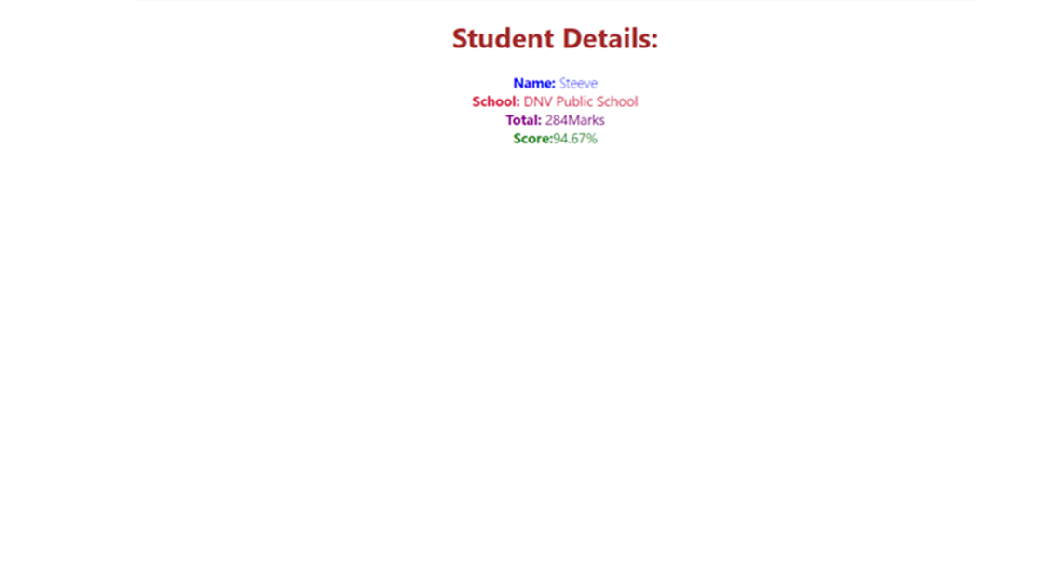

**EX.NO: 4 Create React app tool with the name as “blogapp”**

CODE:

App.js:

import React from 'react';

import './App.css';

import Posts from './Posts';

function App() {

return (

<div className="App">

<h1>Hello from App.js</h1>

<Posts />

</div>

);

}

export default App;

OUTPUT:

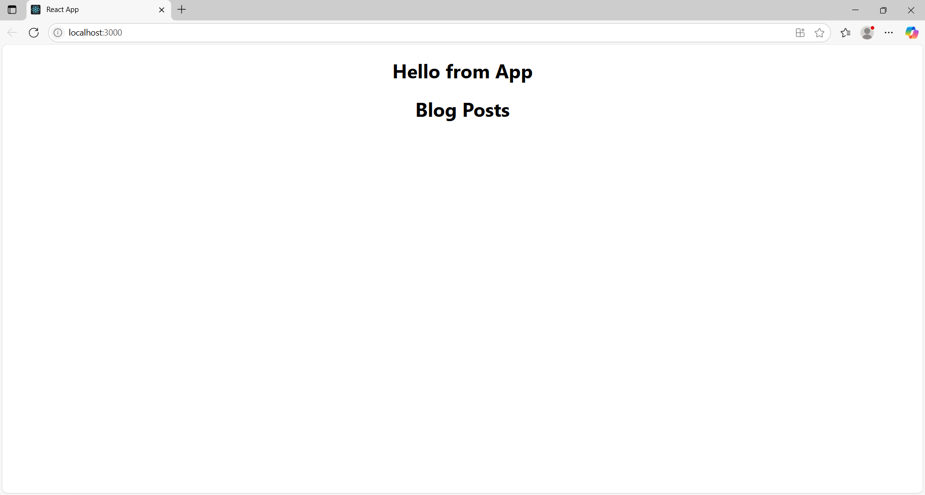

**EX.NO:5 A react application is created which displays the detail of the cohorts using react component.**

CODE:

App.js:

import React from 'react';

import CohortDetails from './components/CohortDetails';

function App() {

return (

<div className="App">

<h1>Cognizant Academy Cohort Dashboard</h1>

<CohortDetails />

</div>

);

}

export default App;

CohortDetails.js:

// CohortDetails.js

import React from 'react';

import styles from './CohortDetails.module.css';

const CohortDetails = () => {

const cohorts = [

{

id: 1,

name: "React Training",

status: "ongoing",

startDate: "2025-07-01",

endDate: "2025-08-01"

},

{

id: 2,

name: "Angular Bootcamp",

status: "completed",

startDate: "2025-05-15",

endDate: "2025-06-15"

}

];

return (

<div>

{cohorts.map((cohort) => (

<div key={cohort.id} className={styles.box}>

<h3 style={{ color: cohort.status === 'ongoing' ? 'green' : 'blue' }}>

{cohort.name} - {cohort.status}

</h3>

<dl>

<dt>Start Date:</dt>

<dd>{cohort.startDate}</dd>

<dt>End Date:</dt>

<dd>{cohort.endDate}</dd>

</dl>

</div>

))}

</div>

);

};

export default CohortDetails;

OUTPUT:

